**Infrastructure Administration (Rob)**

**Recommended Topography**

CyFy recommends the organizations infrastructure include a VPN Server, Firewall, Client workstations, and a Network Attached Storage (NAS) server (figure below).

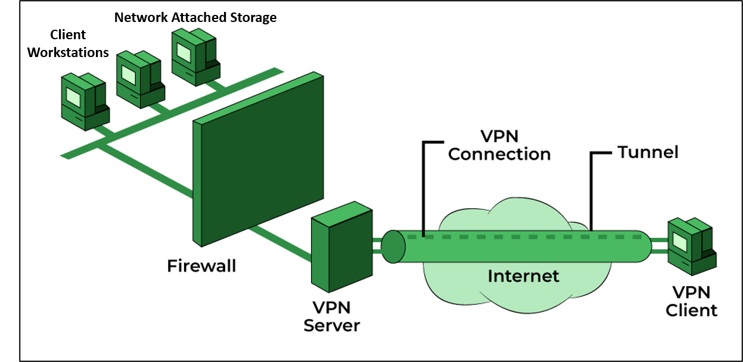

**VPN Server**

CyFy will implement a self-hosted enterprise grade “OpenVPN Access Server” provided by OpenVPN. (https://openvpn.net/wp-content/uploads/access-server-datasheet.pdf).

Cost to utilize OpenVPN’s “Standard” infrastructure is only seven dollars a month and supports 2000 concurrent client workstations.

The organizations OpenVPN Access Server will be installed on a refurbished desktop computer purchased by CyFy. Specifications will include a minimum 12 core 1 GHz Intel Xeon processor and no less than 128MB of RAM. Ubuntu 22.04 LTS will be utilized as a compatible OS (https://openvpn.net/vpn-server-resources/openvpn-access-server-system-requirements/).

**Firewall**

CyFy will implement a pfSense firewall server to filter all packets and content coming to and from the organizations internal network (https://www.pfsense.org/).

CyFy will purchase a refurbished Netgate 6100 Base PFSense+ Security Gateway to support firewall capability (https://www.pfsense.org/products/).

**Network Attached Storage**

CyFy will establish a Network Attached Storage server to support sharing files, endpoint backup services, and recovery procedures. CyFy will purchase a refurbished ‘Synology DiskStation DS1817’ NAS device and two 10 TB hard drives. One hard drive will be used for sharing while the other will be used for backup support & recovery. (https://global.download.synology.com/download/Document/Hardware/DataSheet/DiskStation/17-year/DS1817/enu/Synology_DS1817_Data_Sheet_enu.pdf).

DiskStation DS1817 will be configured with the following settings:

**Client Workstations**

CyFy will provide laptops donated by larger organizations for use as client workstations. These client workstations will be capable of hybrid connectivity, allowing them to connect in office as well as remotely when out of office. CyFy personnel will ensure remote desktop services are enabled prior to issuing out computers.

**Laptop Sanitization**

CyFy will be utilizing the open source DBAN (https://dban.org/) program to ensure all previous data on donated laptops is safely removed.

Below is the step-by-step process CyFy will conduct with the DBAN utility:

**Technology purchase request**

Technology purchase requests must be initially submitted in writing to executive management. If deemed appropriate, CyFy personnel will meet with management and the individual who submitted the request to discuss potential solutions and cost.

CyFy fully understands the need to keep costs down, so will focus on the purchase of refurbished equipment from reputable vendors we have established a working relationship with.

CyFy Equipment Vendors:

* https://www.cxtec.com
* https://www.neweggbusiness.com/t/refurbished